EXECUTIVE GAME THEORY CURRICULUM • 12-WEEK MASTER ARCHITECTURE
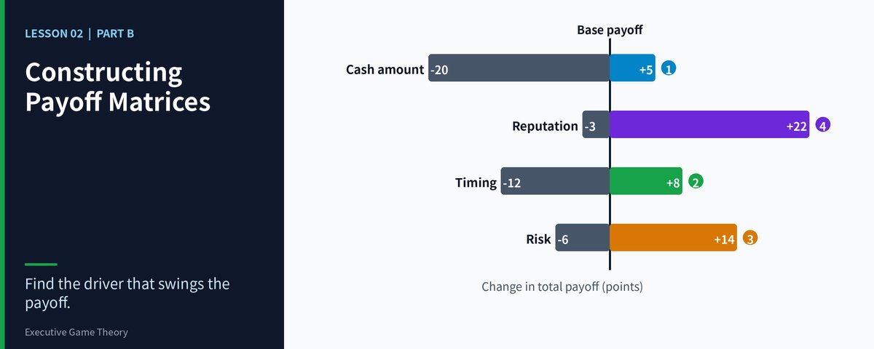

Lesson 02: Constructing Payoff Matrices & Ordinal Utility
Part 2: Intuitive Reinforcement & Strategic Inversion — Projecting Counterparty Survival Priorities
Strategic Focus & Learning Objective: In this topic, we will be learning how to apply the Inversion Reflex to solve the Symmetrical Valuation Blind Spot (projecting your own financial scorecard onto a rival who is fighting for survival).
The Real-World Operational Problem: Decision-makers often cannot understand why a rival launches a seemingly suicidal counter-attack. The root cause is the naive belief that the rival is also maximizing short-term profit, while the rival is in fact fighting to avoid debt liquidation or loss of control.
How This Topic Solves It: By standing in the counterparty's shoes and ranking outcomes ordinally under their survival constraints, you identify the Rank 1 destruction line they cannot let you touch, and you can predict the intensity of their defensive counter-strike. A move that barely matters to you may land exactly on a rival's absolute Rank 1 and trigger a massive, seemingly irrational retaliation that catches an unprepared management team off guard.
■ EXECUTIVE INVERSION ADVISORY Always reason backwards from the rival's insolvency line. If your plan forces a counterparty to face existential ruin, they will respond with a scorched-earth counter-attack that ignores financial cost. Ask yourself: "Which outcome threatens the tenure of the rival's executives or the survival of the company?"

Part I: The 4-Part Prelude Protocol
- Models in Focus: Asymmetric payoff mapping, non-monetary executive utility, and survival-threat modeling.
- Lifelike Dilemma & Problem Statement: A regional logistics carrier cuts bulk container rates by 15%, expecting a heavily indebted incumbent to back down. Instead the incumbent slashes rates by 35%, far below operating cost, and burns millions of its cash reserve. The regional carrier is baffled by this "irrational" suicidal retaliation.
- Component Dissection: The regional carrier evaluated only cash profitability. For the incumbent, losing volume would immediately breach its bank debt covenant and trigger forced loan recall (Rank 1). Burning cash is only Rank 2; being liquidated is Rank 1. Under its true ordinal hierarchy, the deep price cut is entirely rational.
- Lesson Embarkation: We will deconstruct how to map a counterparty's asymmetric payoff hierarchy in order to anticipate an aggressive counter-strike.

Part II: The 7-Stage Core Pedagogy
Your competitor does not share your cost of capital, investor structure or risk tolerance. Inversion analysis forces you to map their survival constraints.
▼ CHECKPOINT: WHAT YOU MUST KNOW BEFORE MOVING FORWARD Never assume your rival thinks like you. A price war that looks irrational is often a rational defense against a hidden debt covenant or a regulatory threat.
Inversion runs in three steps: (1) list the rival's real survival constraints: debt covenants, ownership control, regulatory and investor pressure; (2) stand in the rival's position and rank the four possible outcomes from 4 to 1; (3) test whether your move pushes the rival toward its Rank 1. The table below uses the logistics case from the prelude (ordinal tuple order: regional carrier, incumbent):
Regional Carrier / Incumbent | Incumbent: Hold Rates (No Retaliation) | Incumbent: Cut 35% (Scorched Earth)
Regional Carrier: Cut 15% | (4, 1) [Regional carrier wins share; incumbent trips its debt covenant] | (1, 2) [Incumbent burns cash and retaliates; regional carrier bleeds]
Regional Carrier: Hold Rates | (3, 4) [Status quo; incumbent covenant safe] | (2, 3) [Incumbent cuts for nothing; regional carrier loses share]

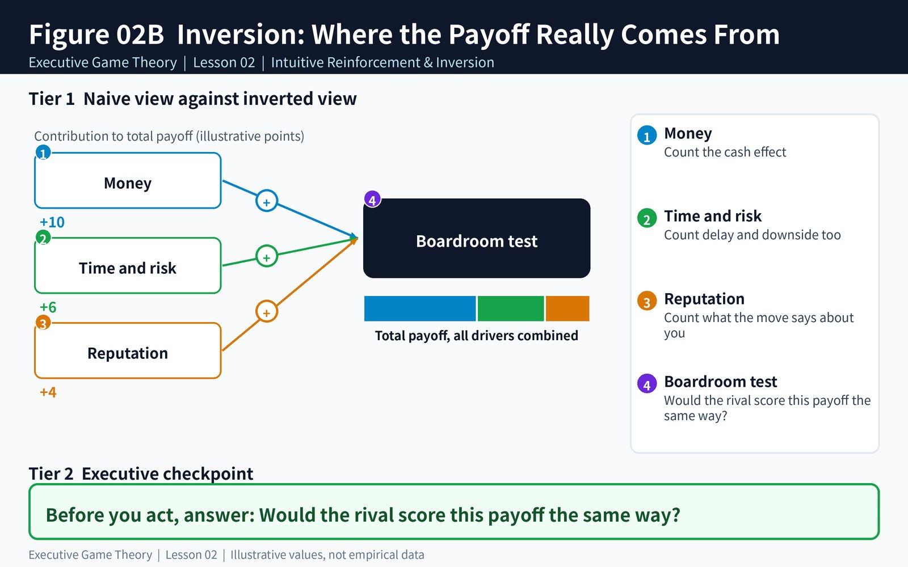
Figure: Lesson 02B — inversion of counterparty payoffs
Figure 2B: The Inversion Reflex (asymmetric payoff mapping from the counterparty's survival view)
Reading the table: when the regional carrier cuts price, the incumbent chooses between two replies. Holding rates is its Rank 1 (covenant default and liquidation); cutting 35% is its Rank 2 (burn cash but survive). The incumbent's rational best response is therefore the scorched-earth counter-attack. That is not madness; it is exact calculation driven by a survival floor.
▼ CHECKPOINT: WHAT YOU MUST KNOW BEFORE MOVING FORWARD Once your move pushes a rival to its Rank 1 survival boundary, the rival will retaliate with unlimited intensity. Build asymmetric moats that do not trigger its survival panic.
- Layer 1 — The Asymmetry Audit Protocol: For every significant rival, list its bank covenant terms, shareholder structure and control pressure, and regulatory licence risk. Then re-rank its 4-to-1 outcomes and compare them side by side with your own. Where the two rankings differ most is where "unexpected retaliation" is most likely.
- Layer 2 — The Solvency vs. Profitability Blind Spot: Profitability reads the income statement; solvency reads cash and debt maturities. A profit loss can be tolerated for several quarters, while a solvency crisis can end the company on a single covenant test date. Any move that touches a rival's solvency floor should be presumed to provoke a cost-ignoring counter-attack.
- Layer 3 — Regulatory and Investor Governance Boundaries: Listed companies have an implicit Rank 1 on share price and credit rating, regulated firms on their licence, venture-backed firms on the next-round valuation. Include these governance boundaries in the rival's ranking to judge which competitive moves are safe and which will detonate an irrational-looking response.
▼ CHECKPOINT: WHAT YOU MUST KNOW BEFORE MOVING FORWARD Audit first, act second. If you cannot write down the rival's top three survival constraints, you are not qualified to start a price war.
- Telecom 5G Spectrum Auctions (Overbidding): A carrier protecting its licence and core customer base bids far above its financial model. A rival who infers its bid only from return on investment will underestimate how firmly it treats losing spectrum as Rank 1.
- Enterprise SaaS (Bundling to Stop Churn): When churn approaches a financing-covenant red line, an incumbent uses predatory bundling to push prices below marginal cost. A challenger who dismisses this as irrational will misjudge how long it lasts.
- Contract Manufacturing (Volume Guarantees): A contract manufacturer accepts zero-margin volume guarantees to satisfy a bank's capacity-utilization covenant. A buyer who compares only quotes will miss the negotiating room and the risk behind this "survival order".
▼ CHECKPOINT: WHAT YOU MUST KNOW BEFORE MOVING FORWARD In every case, find the rival's covenant red line or licence red line. The red line determines how much the rival will pay for an outcome that looks not worth fighting for.
Scenario: Your company plans to win business in a rival's core region with a 10% discount. You learn the rival recently signed a bank loan with a financial covenant that revenue may not fall more than 8% year on year. What is the rival's most likely reaction? A) Do nothing, because a 10% discount is too small to trigger a response. B) Retaliate far harder than your discount, because a revenue decline would trip the covenant. C) Propose a joint price increase. D) Impossible to judge.
Recommended Answer — B: The covenant turns "revenue decline" into a Rank 1 risk for the rival. Even a modest discount that could push its revenue toward the 8% line will draw a cost-ignoring counter-attack. The rational course is to avoid its core region or to offer an alternative that does not touch its revenue red line.
▼ CHECKPOINT: WHAT YOU MUST KNOW BEFORE MOVING FORWARD Ask the right question: not "is the rival profitable?" but "which red line is the rival standing on?"
■ THE DAILY LIFE TRANSLATION You think the other driver is fighting you for a parking space, but he is rushing a family member to the emergency room. For him, Rank 1 is "being late", not "losing face". When you cannot read why someone reacts so fiercely, do not rush to call them irrational. First ask: what are they most afraid of losing right now?
▼ CHECKPOINT: WHAT YOU MUST KNOW BEFORE MOVING FORWARD A reaction that looks irrational is usually just a ranking you have not seen.
Pick a competitor or negotiating counterparty you face now. Write down their four possible outcomes and rank them 4 to 1 from their position. Then test whether your next move pushes them toward their Rank 1. Practise afterwards in the companion simulation engines below.
▼ CHECKPOINT: WHAT YOU MUST KNOW BEFORE MOVING FORWARD Five minutes spent writing down the other side's ranking before each move is far cheaper than five quarters spent cleaning up afterwards.

Topic 02 Companion Games: Operational Briefing & Deployment
- Pedagogical Intent: Train inversion thinking and ordinal ranking into a boardroom reflex through twin interactive engines.
- Executive Objectives: Game 1 (Matrix Gridlock): identify and avoid Rank 1 trap cells in a 2×2 grid. Game 2 (Factory Capacity War): over 3 production cycles, anticipate an aggressive rival's counter-strike intensity and allocate capex.
- Scoring Standards: Passing the calibration quiz in Game 1 activates a 200% Entry Buff. Game 2 carries DOUBLE WEIGHT (2x) on the unified leaderboard.
- Game 1 (Matrix Gridlock): https://firedancerx.github.io/Game-Theory/Games/Lesson%2002/game1_matrix_gridlock.html
- Game 2 (Factory Capacity War): https://firedancerx.github.io/Game-Theory/Games/Lesson%2002/game2_factory_capacity_war.html
- Master Platform Portal: https://firedancerx.github.io/Game-Theory/

Appendix: Obsidian Knowledge Graph Semantic Triplets
Import these atomic triplets into your executive knowledge vault (Obsidian / Logseq):
Obsidian Raw Semantic Triplets (Copy & Paste into Vault)
Concept Entity | Historical Origin & Date | Obsidian Semantic Triplets | Executive Commercial Meaning
[[Utility Asymmetry]] | Executive Decision Science Standard (2026) | [[Utility Asymmetry]] --[determines]--> [[Retaliation Intensity]] | The rival ranks outcomes differently from you, so its reaction cannot be predicted from your metrics.
[[Survival Imperative]] | Survival constraints and rational-choice research tradition | [[Survival Imperative]] --[overrides]--> [[Book Profit Optimization]] | When the firm's existence is threatened, the rival abandons profit optimization and defends itself at any cost.
[[Debt Covenant Red Line]] | Financing-covenant and financial-constraint practice | [[Debt Covenant Red Line]] --[defines]--> [[Rival Rank 1]] | Bank covenant terms are the rival's hardest floor; touching one triggers a liquidation-grade counter-attack.

